Caribbean Advanced Proficiency Examination

Accounting Internal Assessment



Topic: An assessment into the financial statements of LASCO Manufacturing Limited between the years 2019 to 2020 to determine the performance of the business through ratio analysis in terms of profitability and liquidity

**Centre:** Mona High School

**Centre Number:** 100152

**Name of Candidates:** **Candidate’s Number:**

Syee Dassado 1001520219

Chevannese Ellis 1001520286

Joel Trowers 1001520782

Jevane Ricketts 1001520677

**Teacher:** Ms. Sasha Laing

**Territory:** Jamaica

**Year:** 2021-2022

***Table of Contents***

Acknowledgement III

Introduction IV

Topic V

Objectives VI

Literature Review VII

Methodology IX

Presentation of Data X

Data Analysis XIII

Evaluation of Data XIV

Recommendation XVI

Conclusion XVII

Appendix XVIII

Bibliography XIX

# Acknowledgement

First of all, we want to thank you God for giving us the strength to complete this assignment. Second, we want to express gratitude to our teacher, Ms. Laing, for using her time to help us. Finally, we want to thank our parents for providing the resources we need to finish the project.

# Introduction

LASCO Manufacturing Limited, once known as LASCO Food Successors Limited, was established in October 1994 and is owned and operated by CEO, Lascelles A. Chin. LASCO Manufacturing Limited was registered under the Company's Office of Jamaica as a public limited company prior to its initial public offer on the Jamaica stock exchange market. Products offered by LASCO Manufacturing Limited include; Lasco fruit drink, Lasoy Lactose-free, Lasco whole milk, etc. and services offered by LASCO Manufacturing Limited are; distribution and supply chain and other customer affairs. LASCO as a business itself is not only comprised of manufactured goods but also financial services such as; money transfer, currency exchange, consumer loans, and other investment options. Therefore, the researchers are interested in this firm to assess their financial performance during the period specified in the topic through the use of ratio analysis in terms of profitability and liquidity ratios.

# Topic

An assessment into the financial statements of LASCO Manufacturing Limited between the years 2019 to 2020 to determine the financial performance of the business.

# Objectives

1. To ascertain the ability of Lasco Manufacturing Limited to raise cash to secure the firm’s liabilities with the use of liquidity ratios.
2. To determine the effectiveness of Lasco Manufacturing Limited’s financial position in a market with the use of the profitability ratios.
3. To discover how productive the specified firm is using their resources to generate revenue with the use of efficiency ratios.

# Literature Review

The performance of a business is mainly focused on the ability of a firm to execute arrangements with the objectives of creating a suitable good or service to satisfy the customers' needs and ultimately generate profit. This can be evaluated via Ratio analysis. According to (Bloomenthal, 2021) ratio analysis is a quantitative method of gaining insight into a company's liquidity, operational efficiency, and profitability by studying its financial statements such as the balance sheet and income statement.

Pertaining to the details of ratio analysis, an article written by (Lumen Learning, 2021) implies the introduction of the types of ratio analysis and its significance. It states "There are various types of financial ratios, grouped by their relevance to different aspects of a company’s business as well as their interest to different audiences. Financial ratios may be used internally by current and potential shareholders and creditors of a firm and other audiences interested in understanding the strengths and weaknesses of a company, especially compared to the company over time or compared to other companies." So it seems it would be futile to have the results of ratio analysis with only one period. Rather insights can be derived by comparing the analysis over more than one accounting period to see whether the performance of the business is being optimized.

To be aligned with the goals of this project, (Bloomenthal, 2021) explained the concept of both liquidity and profitability ratios. It states “liquidity ratios measure a company's ability to pay off its short term debts as they become due, include the current ratio, quick ratio, and working capital ratio." It was discerned that either internal or external examiners use liquidity ratios to identify the value of the firm's resources to be converted in cash to cover abrupt liabilities to prevent bankruptcy. It also indicates that if a firm flunks to carry to execute such an act, this could be due to difficulties in sustaining its sales growth like not collecting payments from debtors in a suitable, limited time frame.

Lastly, (Haynes, 2021) expressed that profitability ratios are a class of financial metrics that are used to assess a business's ability to generate earnings relative to its revenue, operating costs, balance sheet assets, or shareholders’ equity over time, using data from a specific point in time. Profitability ratios can be compared with efficiency ratios, which consider how well a company uses its assets internally to generate income. The inference depicted denotes the ability of how well a firm utilizes its resources can impact the firm's profitability since greater production yields a lower cost per unit.

# Methodology

This research was conducted on the topic; An assessment into the financial statement of Lasco Manufacturing Limited between the years 2019 to 2020 to determine the performance of the business through ratio analysis in terms of probability and liquidity. The research techniques that were used to collect data were observation and an interview.

 An observation is a method of collecting data that is systematic viewing or deliberate study through the eye. Observation may be done in a natural or stimulated situation. The reason why the data collection method was chosen is because it will help the researcher to analyze and compare the financial statements for each year. It is a very simple method to use and provides very accurate information. The observation was conducted on February 14, 2022 to compare the financial statements between the two year periods of LASCO. When gathering and comparing the information, it took a total of four hours to properly evaluate the statements which was a disadvantage of observation as not everything could be observed.

# Presentation of Data

**Figure 1:** Represents a comparison of the totals of assets, liabilities, and equity for the financial year 2019 and 2020.

**Figure 2:** Showing the comparison of the return on capital for the period of 2019 to 2020.

**Figure 3:** Showing the comparison of the Net Profit Margin between the periods of 2019 to 2020

**Figure 4:** Shows the comparison of the Inventory Turnover in the period of 2019 to 2020

**Figure 5:** Showing the comparison of the Acid Test Ratio between the periods of 2019 to 2020

# Data Analysis

Figure one represents the comparison of the total assets, liabilities, and equity for the financial year 2019 to 2020. In the year 2019, the total assets were 8.8 million and in 2020, 9.7 million. There was an increase of nine hundred thousand between the years. The total liabilities for both years remain the same at 3million. And the total equity for 2019 was 5.9 million whilst in 2020, it was 6.8million which means an increase of nine hundred thousand dollars happened between the years.

Figure two shows the comparison of the return on capital for the periods of 2019 to 2020. In 2019, the capital ratio for the company was 18% however in 2020 the capital ratio amounted to 15%. A 3% decrease happened during this period.

Figure three shows the comparison of the net profit margin between the periods of 2019 to 2020. In 2019 the Net Profit margin was 14% but in 2020 it was 12%. There was a 2% decrease between the period of 2019 and 2020 for the Net Profit Margin.

Figure four shows the comparison of the inventory turnover in the period of 2019 to 2020. In 2019, the inventory turnover was 4.13 times whilst in 2020 it was 4.25 times. Between this period, there was a 0.12 times increase that occurred.

# Evaluation of Data

The financial statement of LASCO Manufacturing Limited was utilized in calculating and representing the ratio analysis to analyze the operation of the organization. These ratios were characterized by efficiency, profitability, and liquidity.

Firstly, as seen in Figure one, there was an increase of nine hundred thousand in the value of assets during the period specified. This implies that the firm may have used up some of its reserve or income earned in 2019 to invest in more assets for progressive growth of the operation of the business. This also correlates to Figure five, which depicts a growth in the acid test ratio. Possibly since more assets were injected, the organization may had substantially more assets than liabilities which mean the firm could cover its short-term or long-term obligation. This also leads to why the firm was also able to cover their liabilities because the amount owed remains the same during the period represented in Figure one as well. Additionally, the firm's acid test ratio surpassed 1:1, proving that the test ratio was favorable.

Secondly, a relationship was identified between the results of the increase of the capital's value and the decline in its return on capital shown in Figure one and Figure two respectively. This shows that LASCO Manufacturing Limited had excessive capital and was not efficiently running the usage of this growth in capital to sustain the business enough by generating more profits from the capital employed. This may also include holding on to unused, obsolete materials which are likely to reduce the return on capital. Ultimately, this indicates the loss of competitiveness since many large manufacturing firms are of capital-intensive types, meaning they predominantly rely on capital for their economic growth in their target market.

Lastly, in Figure four, there was a slight increase in the inventory turnover during the period. In contrast, there was a reduction in the net profit margin as depicted in Figure three. Even though a company is selling goods quickly does not mean there will be an increase in net profit. Consequently, this decline in profit may be due to an increase in expenditures like overhead expenses. Additionally, there may have also been an increase in the price of raw materials which may not have been passed on to its customers.

# Recommendation

It has been observed that LASCO Manufacturing Limited has attained remarkable results within the financial year 2019 and 2020. However, flaws were identified during our research in financial performance. Below are a few recommendations that are advised:

1.     Try using capital more efficiently. Having excess capital will cause inefficiency in the company which in turn hinder your growth.

2.     Keep expenses and expenditures on a lower level. Having an excessive amount of expenses to pay and too much outflow of money on extra raw materials will reduce net profit.

# Conclusion

This research is aimed to ascertain the financial performance of LASCO Manufacturing Limited through liquidity and profitability ratios and it was a success in completing this research. It's fair to say that LASCO Manufacturing Limited has improved tremendously from the financial year of 2019 to 2020 in the aspects that were researched. It is impressive that they attained a higher financial performance in 2020 than 2019 which shows elevations to higher levels.

# Appendix

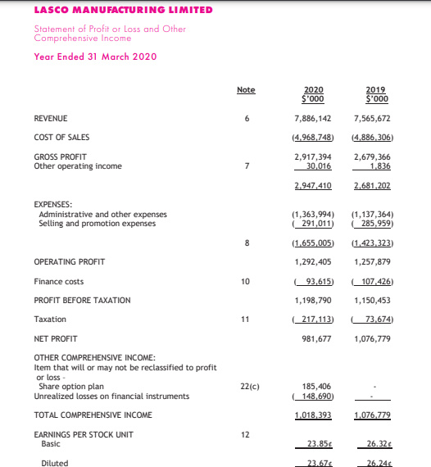

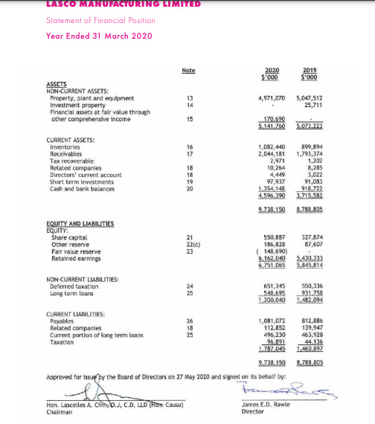

**Tables**

Table 1: Showing the comparison of Ratios during 2019 to 2020

|  |  |  |
| --- | --- | --- |
| **Name of Ratio** | **2019** | **2020** |
| Return on Capital | 18% | 15% |
| Net Profit Margin | 14% | 12% |
| Inventory Turnover Ratio | 4.13 times | 4.25 times |
| Acid Test Ratio | 1.927 | 1.966 |

**Table 2:** Represents the values of assets, liabilities and equity for the financial year 2019 and 2020.

|  |  |  |
| --- | --- | --- |
| ***Totals*** | ***2019*** | ***2020*** |
| Total Assets | $8,788,805.00 | **$9,738,150.00** |
| Total Liabilities | $2,942,991.00 | **$2,987,085.00** |
| Total Equity | $5,845,814.00 | **$6,751,065.00** |

**Formulas used in Ratio Analysis:**

**Figure 2**

2019

$\frac{Net Profit/Loss}{Capital Employed} ×100=Return on Capital$ $\frac{\$1,076,779}{\$5,845,814} ×100=18\%$

2020

$\frac{Net Profit/Loss}{Capital Employed} ×100=Return on Capital$ $\frac{\$981,677}{\$6,751,065} ×100=15\%$

**Figure 3**

*2019*

$\frac{Net Profit/Loss}{Net Sales} ×100=Net Profit Margin$ $\frac{\$1,076,779}{\$7,565,672} ×100=14\%$

*2020*

$\frac{Net Profit/Loss}{Net Sales} ×100=Net Profit Margin$ $\frac{\$981,677}{\$7,886,142} ×100=12\%$

**Figure 4**

*2019*

$\frac{Total Current Asset}{Closing Stock}=Inventory Turnover$ $\frac{\$3,715,582}{\$899,894}=4.13$ times

*2020*

$\frac{Total Current Asset}{Closing Stock}=Inventory Turnover$ $\frac{\$4,596,390}{\$1,082,440}=4.25 times$

**Figure 5**

*2019*

$\frac{Current Assets-Closing Stock}{Current Liabilities}=Acid Test Ratio$ $\frac{\$3,715,582-\$899,894}{\$1,460,897}=1.927$

*2020*

$\frac{Current Assets-Closing Stock}{Current Liabilities}=Acid Test Ratio$ $\frac{\$4,596,390-\$1,082,440}{\$1,787,045}=1.966$

# Bibliography

Adam Hayes. (2022). Acid Test Ratio.

<https://www.investopedia.com/terms/a/acidtest.asp>

Andrew Bloomenthal. (2021). Ratio Analysis.

<https://www.investopedia.com/terms/r/ratioanalysis.asp>

LASCO Manufacturing Limited. (2020). Lasco Manufacturing Limited Annual Report 2020.

<https://www.jamstockex.com/lasco-manufacturing-limited-lasm-annual-report-2020/>

LASCO Manufacturing Limited. (2021). Lasco Manufacturing Limited Annual Report 2021.

<https://jamstockex.com/lasco-manufacturing-limited-lasm-annual-report-2021/>

Lumen Learning. (2021). Overview of the Ratio Analysis.

<https://courses.lumenlearning.com/boundless-finance/chapter/overview-of-ratio-analysis>